**VISHWAKARMA INSTITUTE OF INFORMATION TECHNOLOGY, PUNE**

**COMPUTER ENGINEERING DEPARTMENT**

**APRIL-MAY 2018**

**Synopsis**



**Group number : BE/PRJ/18-19/32**

Group Members :

1. Shashank Kapile 421007.

2. Hrushikesh Baravkar 421018.

3. Sarthak Gophane 421045.

4. Saurabh Koshatwar 421069.

Email-ID :

1. Shashank Kapile [shashank.kapile@viit.ac.in](mailto:shashank.kapile@viit.ac.in) 9766989988

2. Hrushikesh Baravkar [hrushikesh.baravkar@viit.ac.in](mailto:hrushikesh.baravkar@viit.ac.in) 9766954261

3. Sarthak Gophane [sarthak.gophane@viit.ac.in](mailto:sarthak.gophane@viit.ac.in) 8805395521

4. Saurabh Koshatwar [saurabh.koshatwar@viit.ac.in](mailto:saurabh.koshatwar@viit.ac.in) 7387725884

**Title :** Neuro – Spine Medical Data Analytics

**Objective :**

* **Data Acquisition :-** To gather detailed data related to spines from multiple sources like previous hospital records, personalized multiple choice questions, etc.
* **Patient Profiling :-** Creation and analysis of personalized patient profiles and reports visualization.
* **Pattern Recognition on data :-** Analysis of the data collected to recognize multiple patterns and trends to tackle various spine related issues.
* **Remedy Recommendation :-** Recommending remedies for issues recognized through patterns and individual patient profiles.

**Abstract :**

The Neuro – Spine Medical Data Analytics System(NSMDAS) is a system which would assist doctors and patients get effective analysis and deeper insights about the issues raised due to poor body posture. NSMDAS will provide detailed analysis related to various problems occurring at different spinal regions and would also suggest remedies to temporarily overcome the pain in the affected regions. The system would analyze and extract information from various patients text reports generated through multiple tests taken by the patient.

The NSMDAS would also train itself from the data collected from upcoming patients and would also predict the problem the patient is likely to face in the near future. The NSMDAS would also provide visualizations about a particular individual or group of individuals to study patterns and analyze the problems to the root cause and tackle them more effectively.

**Briefs about Contents:**

1. **Introduction :**

The Neuro – Spine Medical Data Analytics System(NSMDAS) would provide doctors with deeper analysis and insights into data generated through monitoring the posture in day to day activities. In addition to the monitoring and analysis, the system will provide detailed analysis and would also suggest effective remedies to temporarily overcome them. The system would also provide various visualizations which would also help doctors to make effective and informed decisions.

1. **Technical Details :**

|  |  |  |
| --- | --- | --- |
| **Type** | **Software** | **Hardware** |
| Mobile Application | Android Operating System  Android Lollipop and upper versions | 1. RAM – 1 GB  2. Storage – Below 10 MB |
| Database Server | Oracle Database Server and MongoDb |  |
| Application Server | Linux Operating System / Amazon Web Services |  |
| Programming Languages | Python / R, Java, Spring Boot |  |

1. **Working :**

The Neuro – Spine Medical Data Analytics System consists of analytics done on data gathered from two components : a mobile application and posture detection module. The mobile application is the main component as major analysis would be provided on mobile application itself. The posture detection module is used the get the real time data of the posture the patient is currently wearing. The system would consist of a centralized server where all the pre-processing and analysis would be done and the output would be transferred back to mobile application.

The mobile application would create an individual patient profile so that doctors can monitor and analyze each patient individually. The mobile application would be used to gather current information about the patient through MCQ’s, graphical representations and the posture detection module to send it to the server. The server would then analyze the information based on all the training done till date and would provide predictions to the problem analyzed. It would also suggest remedies that need to be taken by the patient.

The training of the model would be done through data gathered by multiple sources like MCQ, graphical representation, previous Hospital datasets and Posture detection module data. The system would also perform textual information extraction on patients text reports generated through various medical tests taken. The model would provide solutions to general and specialized problems as well. The model would map the pattern and the traits using current input given and would offer solutions. The data would be stored completely on the database server for easy access. The doctors would be able to get insights through various visualization graphs for multiple categories of patients.

The remedy recommendation would include various exercise suggestion and generic medical remedies that are easily available. The system would allow doctors to effectively map various types of patients to different categories and take more informed decisions.

**System Architecture :-**

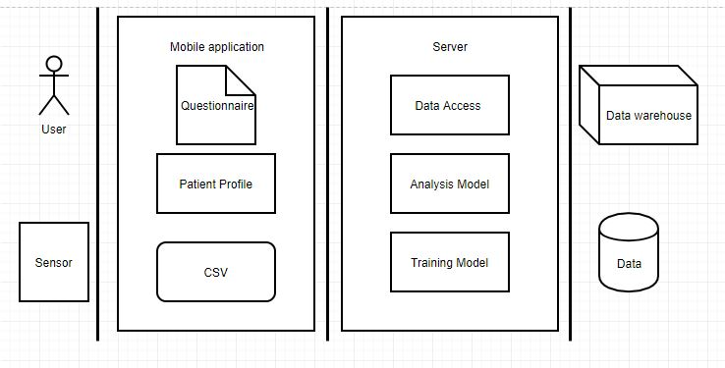

**Use Case Diagram :-**

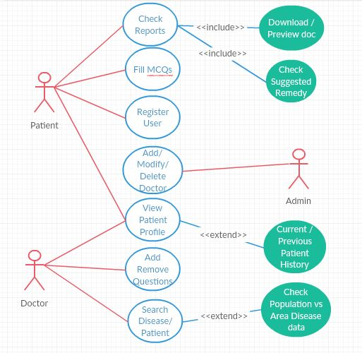

1. **Applications:**

* Medical Research
* Medical Surveys
* Sports :- Can be used by atheletes if they suffer from back pain due to exercises.
* Can be used by senior citizens for back pain
* Can be used by people who have sedentary jobs
* Can be used by doctors who specializes in spine like cairopractors, Orthopedic doctors, Neuro surgeon, etc.

**References/Bibliography:**

[1] Harsh Gupta, Smartphone Based Cervical Spine Stress Prevention

[2] E Widerstro, F Biering-Sørensen, TN Bryce, DD Cardenas, NB Finnerup, MP Jensen, JS Richards and PJ Siddal, The International Spinal Cord Injury Pain Basic Data Set

[3] Department of Health and Human Services, Observation based Posture Assessment.

[4] A. Hermanis, K. Nesenbergs, R. Cacurs, and M. Greitans, Wearable Posture Monitoring System with Biofeedback via Smartphone

[5] Da-Yin Liao, Collaborative, Social-networked Posture Training (CSPT) through Head-and-Neck Posture Monitoring and Biofeedbacks